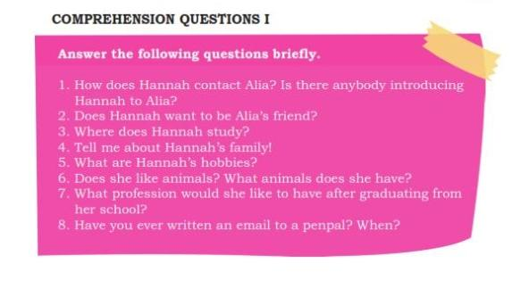
- Hannah contact’s Alia by email. Yes there is, caroline is introducing Hannah to alia
- Yes she does, Hannah want to be Alia’s friend
- Thomas Eddison high school in Minneapolis, Minnesota, USA
- She has two brothers and two half sisters, and she is the middle child. Her father died a few years ago so her mother runs the house and the family business. Her father was a barista.
- She has a lots of hobbies, she likes music-mostly classical and folk music. Amd she likes sports, especially tennis and basketball
- Yes she does, she and her sister have three dogs
- A park ranger, perhaps work for the national parks service
- I’ve never written an email to a pen Pal

